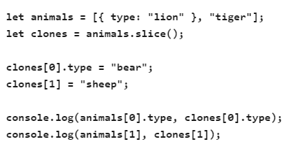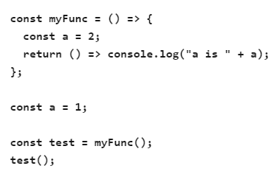

Dom event :

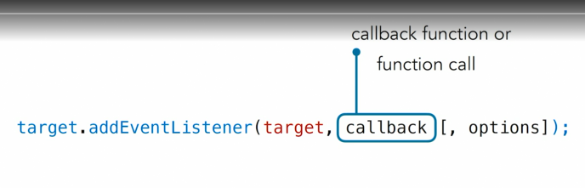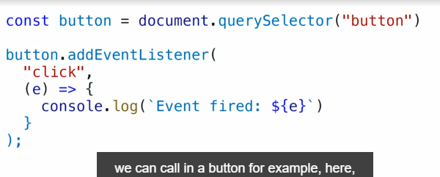

Example

